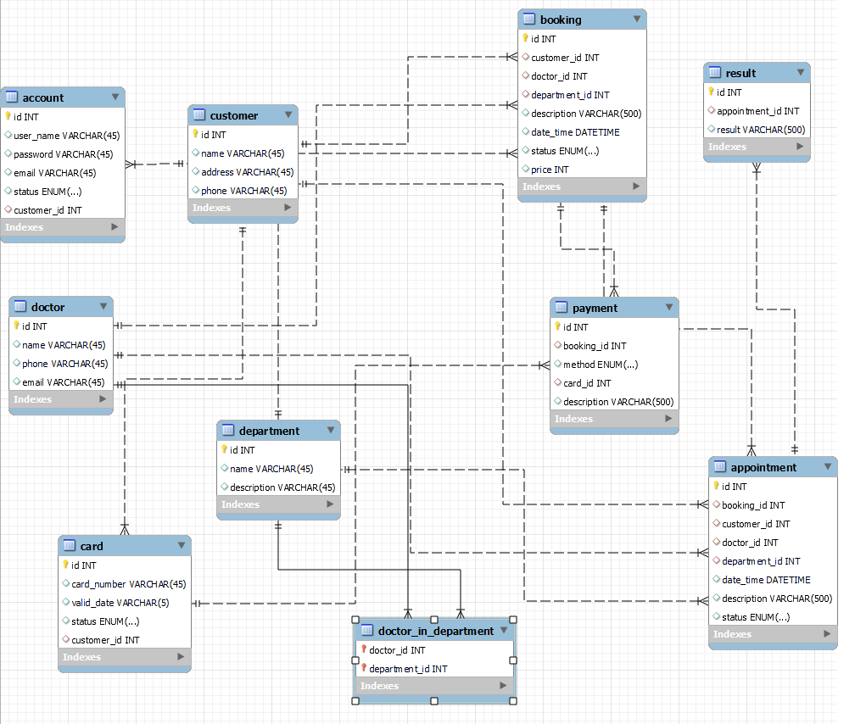

## -- 1. Get Customer who have card in the system and show their cards.

**SELECT**

*cus*.***id***, *cus*.***name***, *c*.***card_number***

**FROM**

***card*** *c*

**LEFT** **JOIN**

***customer*** *cus* **ON** *cus*.***id*** = *c*.***customer_id***

**ORDER** **BY** id;

## -- 2. Get all customers who live in Ho Chi Minh City

**SELECT**

*cus*.***id***, *cus*.***name***

**FROM**

***customer*** *cus*

**WHERE**

*cus*.***address*** **LIKE** **'%HCM%'**;

## -- 3. how many percentages of ACTIVE/INACTIVE account

**SELECT**

***status***,

(**COUNT**(*) * 100) / (**SELECT**

**COUNT**(*)

**FROM**

***account***) **AS** *percentage*

**FROM**

***account***

**GROUP** **BY** status;

## -- 4. Show all Doctor with their skill/departments.

**SELECT**

*dr*.***id***, *dr*.***name***, *dep*.***name***

**FROM**

***doctor*** *dr*

**LEFT** **JOIN**

***doctor_in_department*** *d* **ON** *dr*.***id*** = *d*.***doctor_id***

**LEFT** **JOIN**

***department*** *dep* **ON** *dep*.***id*** = *d*.***department_id***

**ORDER** **BY** *dr*.***id*** **DESC**;

## -- 5. order doctor has most skills/departments to least.

**SELECT**

*dr*.***id***, *dr*.***name***, **COUNT**(*d*.***department_id***) **AS** *total_skill*

**FROM**

***doctor*** *dr*

**LEFT** **JOIN**

***doctor_in_department*** *d* **ON** *dr*.***id*** = *d*.***doctor_id***

**GROUP** **BY** *dr*.***id***

**ORDER** **BY** *total_skill* **DESC**;

## -- 6. which departments does not have doctor?

**SELECT**

*dep*.***id*** *ID*,

*dep*.***name*** *Department*,

**COUNT**(*d*.***doctor_id***) *No_of_doctor*

**FROM**

***department*** *dep*

**LEFT** **JOIN**

***doctor_in_department*** *d* **ON** *d*.***department_id*** = *dep*.***id***

**GROUP** **BY** *ID*

**HAVING** **COUNT**(*d*.***doctor_id***) = 0

**ORDER** **BY** *ID* **DESC**;

## -- 7. which departments has most doctors? how many? which has the least? how many?

**WITH** Noofdoctor **as**(**SELECT** **COUNT**(*d*.***doctor_id***) *n*

**FROM** ***department*** *dep*

**LEFT** **JOIN** ***doctor_in_department*** *d* **ON** *d*.***department_id*** = *dep*.***id***

**GROUP** **BY** *dep*.***id***)

**SELECT**

*dep*.***id*** *ID*,

*dep*.***name*** *Department*,

**COUNT**(*d*.***doctor_id***) *No_of_doctor*

**FROM**

***department*** *dep*

**LEFT** **JOIN**

***doctor_in_department*** *d* **ON** *d*.***department_id*** = *dep*.***id***

**GROUP** **BY** *ID*

**HAVING** *No_of_doctor* = (**SELECT**

**MAX**(***n***)

**FROM**

***Noofdoctor***)

**UNION**

**SELECT**

*dep*.***id*** *ID*,

*dep*.***name*** *Department*,

**COUNT**(*d*.***doctor_id***) *No_of_doctor*

**FROM**

***department*** *dep*

**LEFT** **JOIN**

***doctor_in_department*** *d* **ON** *d*.***department_id*** = *dep*.***id***

**GROUP** **BY** *ID*

**HAVING** *No_of_doctor* = (**SELECT**

**MIN**(***n***)

**FROM**

***Noofdoctor***)

## -- 8. get total imcome each year

**SELECT**

**YEAR**(*b*.***date_time***) **Year**, **SUM**(*b*.***price***) *Income*

**FROM**

***booking*** *b*

**WHERE**

***status*** = **'PAID'**

**GROUP** **BY** **Year**

**ORDER** **BY** **Year** **ASC**;

## -- 9. which department has the biggest average income for every appointment all the time?

**SELECT**

*dep*.***id***, *dep*.***name***, **AVG**(*b*.***price***) *average_income*

**FROM**

***department*** *dep*

**LEFT** **JOIN**

***booking*** *b* **ON** *b*.***department_id*** = *dep*.***id***

**GROUP** **BY** *dep*.***id***

**HAVING** *average_income* = (**SELECT**

**MAX**(*a*)

**FROM**

(**SELECT**

***department_id*** *id*, **AVG**(*b*.***price***) *a*

**FROM**

***booking*** *b*

**GROUP** **BY** *id*) *avg_i*);

## -- 10. show the total sell in the last 12 months.

**WITH** price_per_month **AS** (**SELECT**

**DATE_FORMAT**(***date_time***, **'%y-%m'**) *m*, **SUM**(***price***) *p*

**FROM**

***booking***

**GROUP** **BY** *m*

**ORDER** **BY** *m* **DESC**

**LIMIT** 12)

**SELECT**

**SUM**(***p***) **'12months_income'**

**FROM**

***price_per_month***

## -- 11. in the last 5 months, which payment method has the most payment times. and how many percentages?

**WITH** payment_methods_per_month **AS** (**SELECT**

**DATE_FORMAT**(date_time, **'%y-%m'**) m, p.**method** **method**, **count**(p.**method**) **count**,

**RANK** () **OVER**(**ORDER** **BY** **DATE_FORMAT**(date_time, **'%y-%m'**) **DESC**) rnk

**FROM**

booking b

**LEFT** **JOIN**

payment p **ON** b.id = p.booking_id **WHERE** b.status = **'PAID'**

**GROUP** **BY** m,p.**method**

**ORDER** **BY** m **DESC**

),

last_5_mth_payment_method **AS** (**SELECT**

m, **method**, **count**

**FROM**

payment_methodS_per_month

**WHERE**

rnk < 6

),

count_and_percentage_of_paymentmethods **AS** (**SELECT**

**method**,

**SUM**(**count**) No_of_payment,

**SUM**(**count**) * 100 / (**SELECT**

**SUM**(**count**)

**FROM**

last_5_mth_payment_method) percentage,

**RANK**() **OVER**(**ORDER** **BY** **SUM**(**count**) **DESC**) rnk

**FROM**

last_5_mth_payment_method

**GROUP** **BY** **method**)

**SELECT**

*

**FROM**

***count_and_percentage_of_paymentmethods***

**WHERE**

***rnk*** = 1

## -- 12. Show the total appointments that each doctor take part in

**SELECT**

*d*.***id***, *d*.***name***, **COUNT**(*a*.***id***) *no_of_appointment*

**FROM**

***appointment*** *a*

**LEFT** **JOIN**

***doctor*** *d* **ON** *d*.***id*** = *a*.***doctor_id***

**WHERE**

***status*** = **'DONE'**

**GROUP** **BY** *d*.***id***

## -- 13. Show all information of an appointment of a customer (customer ID = 1)

**SELECT**

*

**FROM**

***appointment***

**WHERE**

***customer_id*** = 1

## -- 14. Which card never pay?

**SELECT**

*cr*.*, **COUNT**(**IF**(*p*.***id*** **is** **null**, **null**, 1)) **AS** *payment_time*

**FROM**

***card*** *cr*

**LEFT** **JOIN**

***payment*** *p* **ON** *cr*.***id*** = *p*.***card_id***

**GROUP** **BY** *cr*.***id***

**HAVING** *payment_time* = 0

## -- 15. Show money paid of each card.

**SELECT**

*cr*.***id***,

*cr*.***card_number***,

**SUM**(**IF**(***price*** **IS** **NULL**, 0, ***price***)) *amount_paid*

**FROM**

***card*** *cr*

**LEFT** **JOIN**

***payment*** *p* **ON** *cr*.***id*** = *p*.***card_id***

**LEFT** **JOIN**

***booking*** *b* **ON** *b*.***id*** = *p*.***booking_id***

**GROUP** **BY** *cr*.***id***

## -- 16. Which doctor cannot use their skill?

**SELECT**

*dr*.***id***,

*dr*.***name***,

**COUNT**(**IF**(*a*.***id*** **IS** **NULL**, **NULL**, 1)) *total_appointment*

**FROM**

***doctor*** *dr*

**LEFT** **JOIN**

***booking*** *b* **ON** *dr*.***id*** = *b*.***doctor_id***

**LEFT** **JOIN**

***appointment*** *a* **ON** *b*.***id*** = *a*.***booking_id***

**AND** *a*.***status*** = **'DONE'**

**GROUP** **BY** *dr*.***id***

**HAVING** *total_appointment* = 0